**Assignment 4**

1. <https://github.com/mariaadolphs/RDD>
2. **Summarize:**

Punishment and Deterrence: evidence from drunk driving, is a paper written by Benjamin Hansen. Where the main objective is to test the effect of harder punishments and sanctions on driving under the influence. (DUI) Where the punishments are limited by strict rules on blood alcohol content (BAC) and previous penalties. The paper shows evidence concerning the effects that the harder the punishment, lower the probability of committing future crimes. Also, Hansen tries to investigate more about different mechanism, in order to provide more information about alternatives that will multiply time windows for recidivism.

In the study Hansen took the advantage of administrative records in the state of Washington from 1995 to 2011. After 1991, WA applied the rule of 0.08 threshold for determining a DUI, and a 0.15 threshold for an aggravated DUI. As a consequence, he used data from 1999-2007, to analyze the causa effect of having BAC above both of the parameters. In addition to this, the paper restrictions those above the legal age, due to different cutoffs apply to this people. Under this context, Hansen try to answer his question (¿Does harder sanctions affect the probability of committing future crimes?) through a regression discontinuity design, under multiple conditions and assumptions.

$$y_{i}=X_{i}^{'}γ+ α_{1}{DUI}_{i}+ α_{2}{BAC}_{i}+ α_{3}{BAC}_{i}*{DUI}_{i}+u_{i}$$

The main results are based on the equation above, where the indicators, signal whether the BCA Falls above the thresholds. Also, the BCA variable is rescaled around the relevant limits, either 0.08 or 0.15; whit Xi, functioning as the vector of controls.

In the results, he first examines the reduce form effect of having BAC over the two thresholds, on future drunk driving. Then, he studied the effect of having BAC over the DUI threshold for all drivers, including the different number of prior tests. After that, the author introduced the study trying to explain the recidivism in a short and a long term, based on different time lapses. In this way, he added the numerous mechanisms that exist due to the type of sanctions potential offenders can receive both in court and out of court.

At the end, Hansen concludes that alcohol abuse continue to be a major public health, where his study evidence concerning the effectiveness of sanctions or punishments, because having a BCA above either the thresholds is associated with reduced repeat drunk driving both in the short and long term. In addition to this, having a BCA over the 0.15 enhanced punishments limit is related with a decline in repeat drunk driving. The author signals, that the experiment does not estimate the full benefits of the sanctions, realizing he can not say how to prevent drunk drivers.

**Replication:**

1. Done

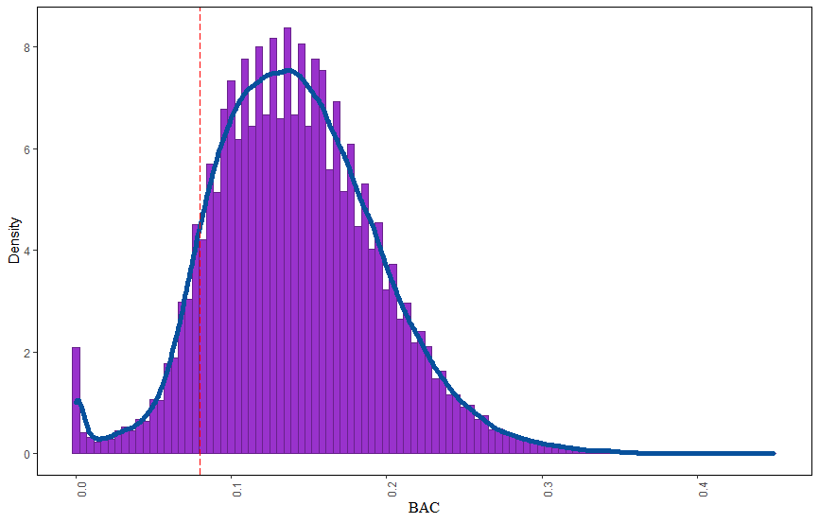

The density test I used is the Mac Cary test, where we can examine the density of observations of the assignment variable, to check if there is discontinuity in the density of the variable at the limits for treatment. Based on our histogram, we can tell, that there is no evidence of manipulation in the BAC.

1. Following the excersise instructions, the results suggest that the covariates are balanced in the cut off. Despite the coefficents are different than the Hence’s results, it shows the same thing, that is there are no evidence of a violation in the smoothness assumption.